right to rent project summary
This project focused on being able to capture more relevant data on a Right to Rent record, surface relevant data on an Account, and provide a smoother experience when progressing through an Opportunity.

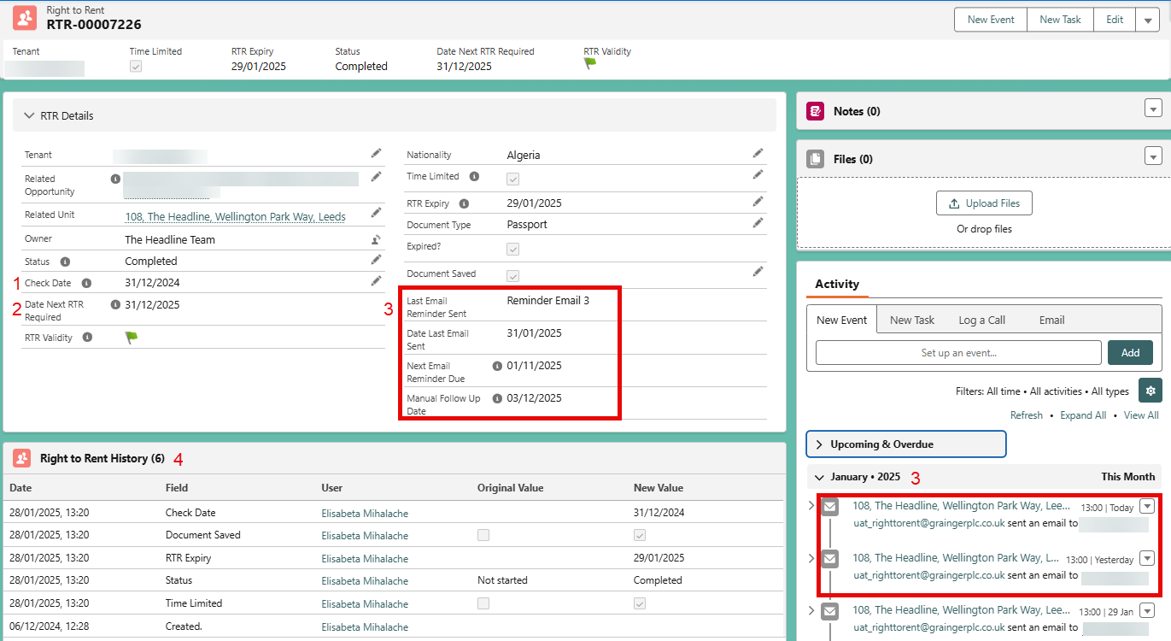Right to rent enhancements

1. Check Date Validation
Validation of the Right to Rent record’s check date to ensure that it is within 28 days of moving in (new lets).

2. Next Check Date
A new date field that will calculate the date of the next check date. This will be the later of either the RTR expiry date or 12 months.

3. Automatic Email Chases and Email notifications
Emails will be sent to people when there Right to Rent is approaching the expiry date. Based on the Next Check Date field, a series of templated emails will be sent at regular intervals prompting the tenant to provide an up to date Right to Rent. If a customer responds to any of these system generated emails, the Right to Rent record owner will be notified, prompting them to review the email. The responses will be added to the Right to Rent record that initiated the email send.
This email threading will also store any attachments that have been sent by the customer.
On the Right to Rent, there are fields that show the last email sent date, what was the last email (Reminder Email 1, Reminder Email 2 etc), the date the next email is due to be sent, and the date that a manual follow up is due.

4. Field History Tracking
The fields that are tracked and shown in the Right to Rent History have been updated to include more important and useful fields and to stop tracking fields that did not make sense to track.

opportunity enhancements

Creating Right to Rents automatically
RTR records are now no longer created automatically whenever a Contact Role is added, and instead created only if there is not an existing valid Right to Rent for that person. This means that tenants that have previously completed a right to rent check and it is still valid (say that they move between two apartments) a new record will not be created. This is the same for renewal and change of sharer opportunities too.

Visibility of all relevant Right to Rent records
On an opportunity, a user will now be able to see the state of any Right to Rents that are related to the Contact Roles. This relates to the above, so that the user can see that all required right to rent checks have been carried out or are still valid whilst on the opportunity.

Prevention of signing contracts
A validation has been introduced to prevent the opportunity stage from progressing without all Right to Rent check being completed.
On an opportunity, a user will now be able to see the state of any Right to Rents that are related to the Contact Roles. This relates to the above, so that the user can see that all required right to rent checks have been carried out or are still valid whilst on the opportunity.

Account enhancements

Single View of Customer – Relevant RTR fields
On an Account, there will be relevant RTR information visible without having to go to the Right to Rent record, providing a snapshot of key details.

general enhancements

List Views
New lists to allow users to manage the RTR process more easily.

